Create Test case for 'GranHub Publish' menu using url '[https://34.154.133](https://34.154.0.133/).

Test case 1: GranHub Publish

**Test case ID** GranHub publish **Test Case Title**:Verify GranHub publish **Test objective**:To ensure that the GranHub Publish functionality works correctly.

**Preconditions**

1. The website should be accessible.
2. User should have a valid email.

**steps to Execute**

1. Open the web browser.

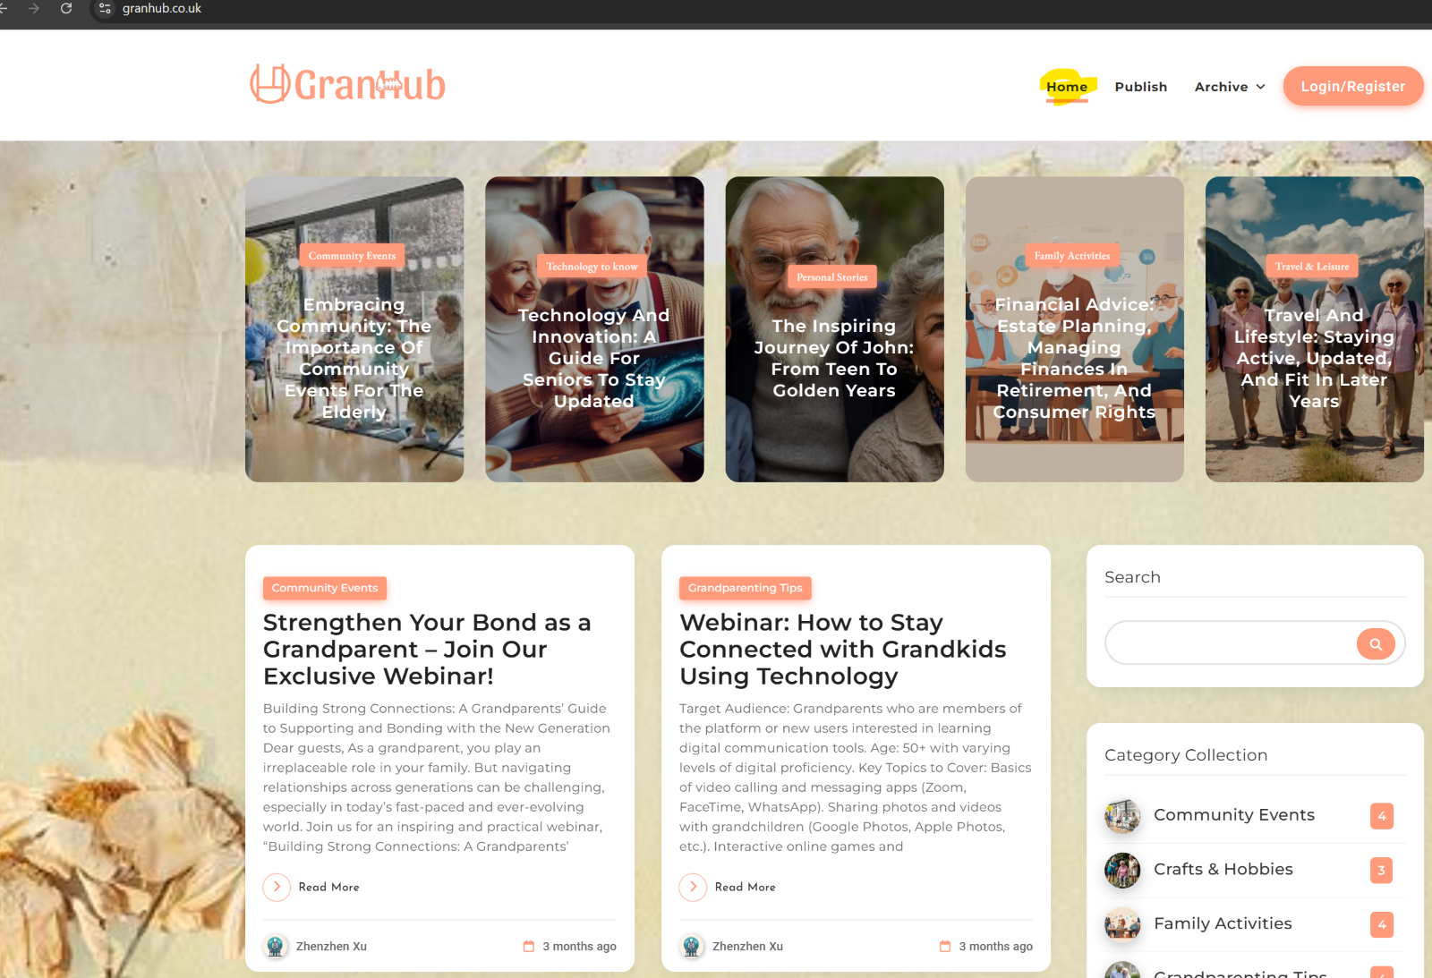

1. Go to the Home| GranHub '[https://34.154.133.96](https://34.154.133.96/)



1. click on the Publish menu from the top header

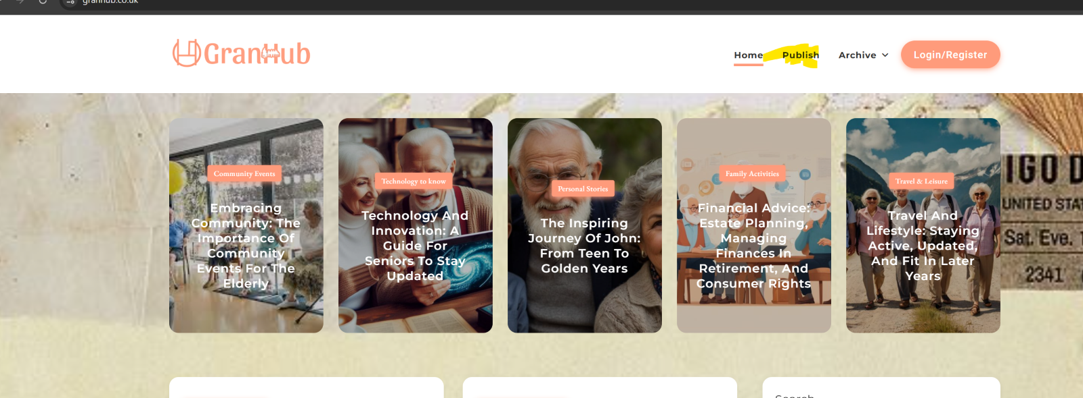

1. Enter the user Email ID and password and click on the submit button.

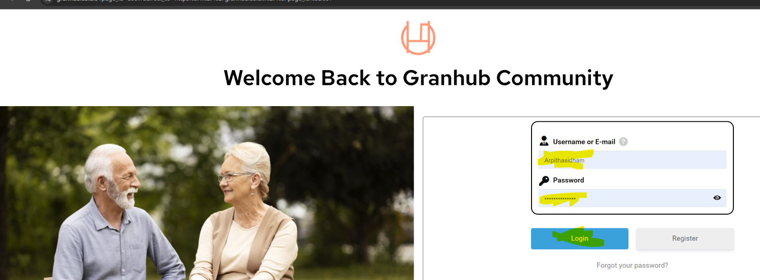

1. We can able to see the page of start blogging.-We need to Enter a Title And select a Post Category.

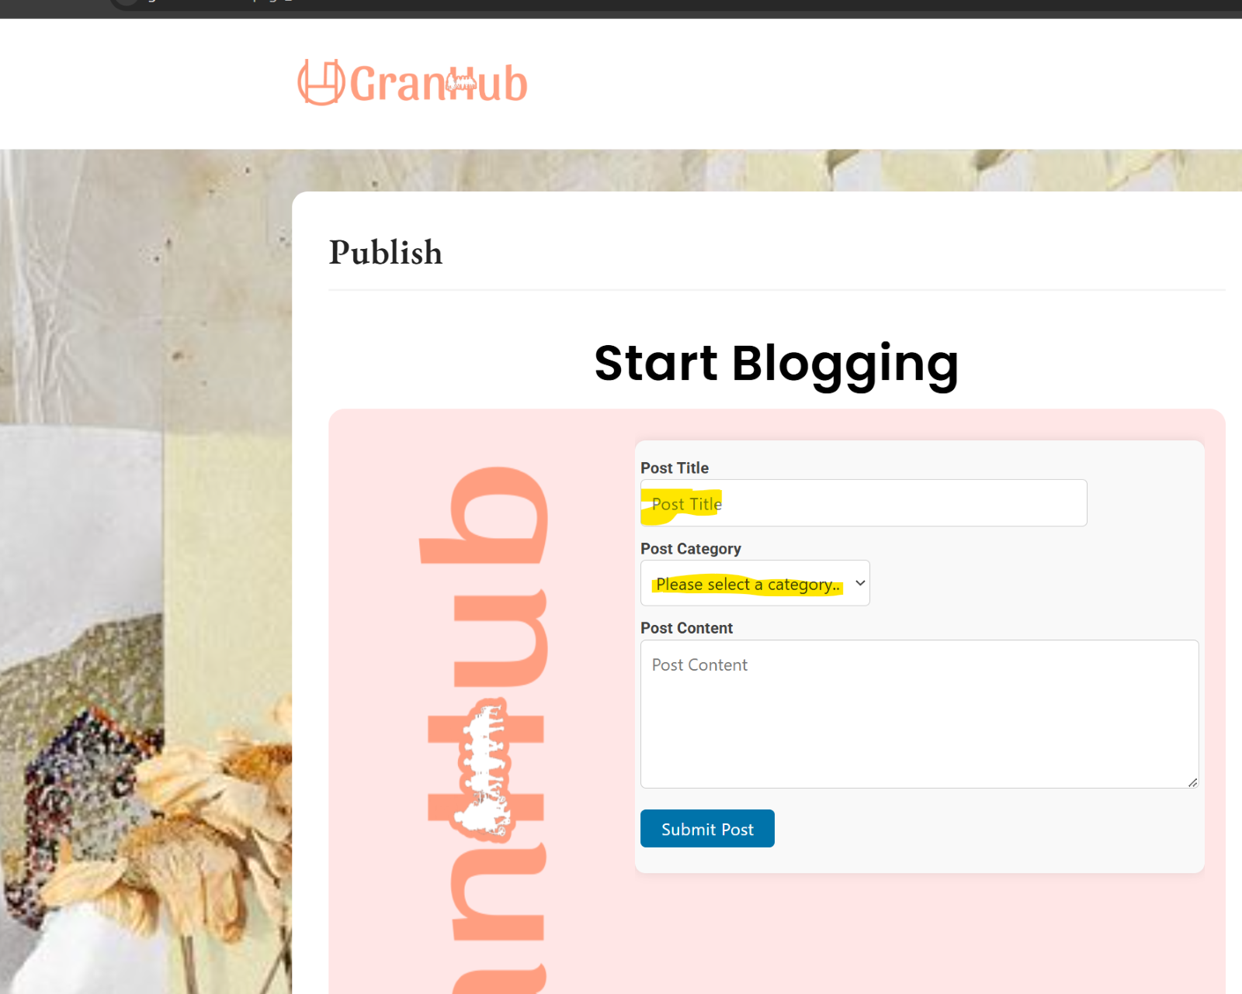

1. Select a Health and wellness and Write post content.

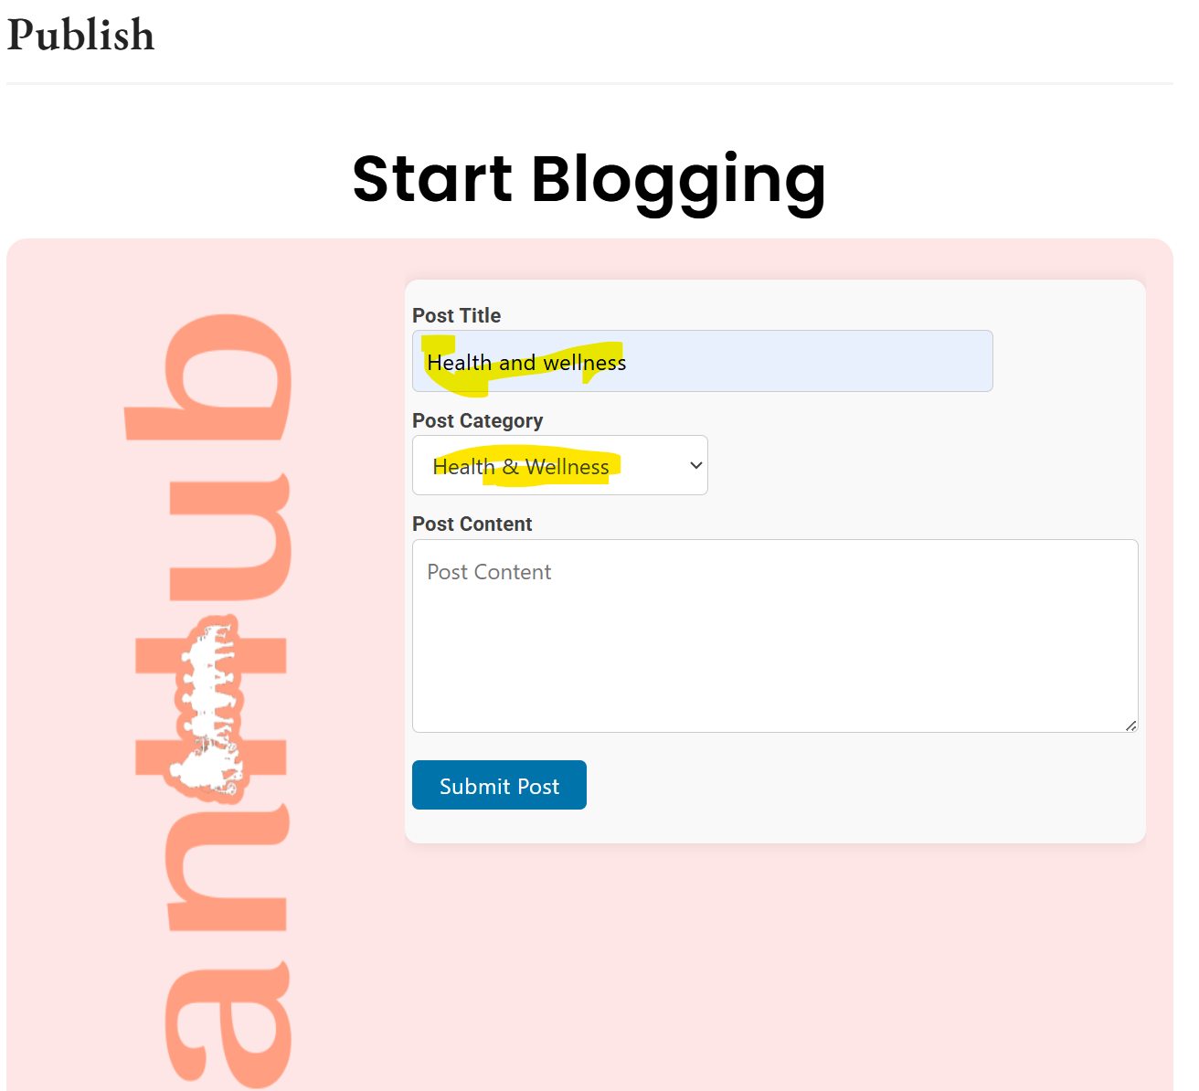

1. Click on the submit button.

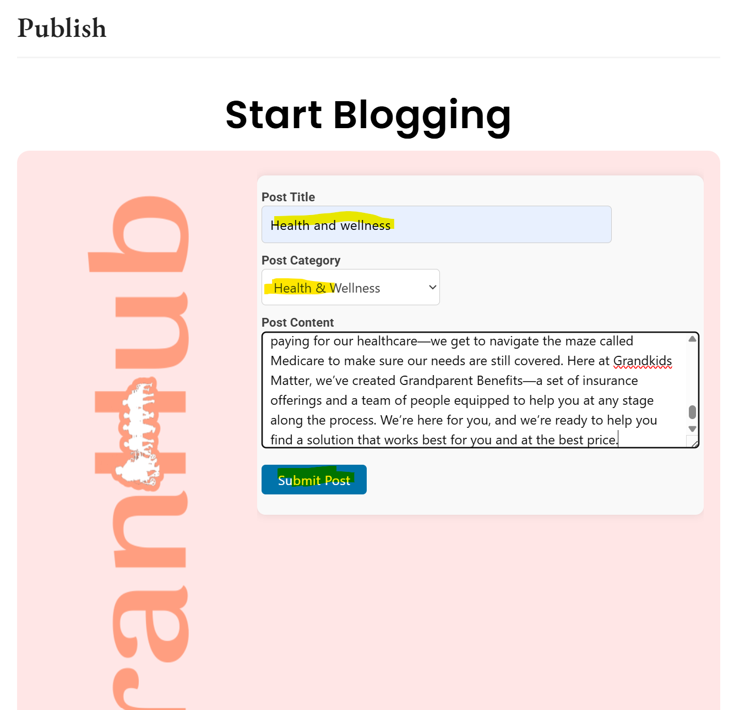

1. Expected results - We can able to see blog in GranHub Home>> Health and Wellness which you have posted.



